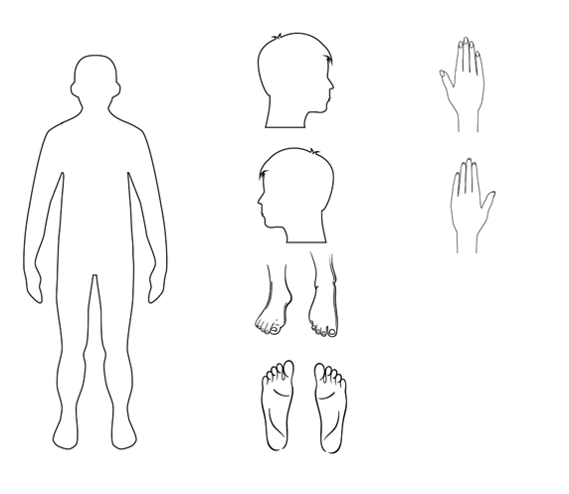

Name of learner

Date of Birth

Name of staff member

Date recorded

Observations